**CECS 544 – BugHound Project**

**Done by**

* **Anthony Martinez**
* **Varun Lingabathini**
* **Sakthi Karthigai Selvi Sekar**

ER – Diagram

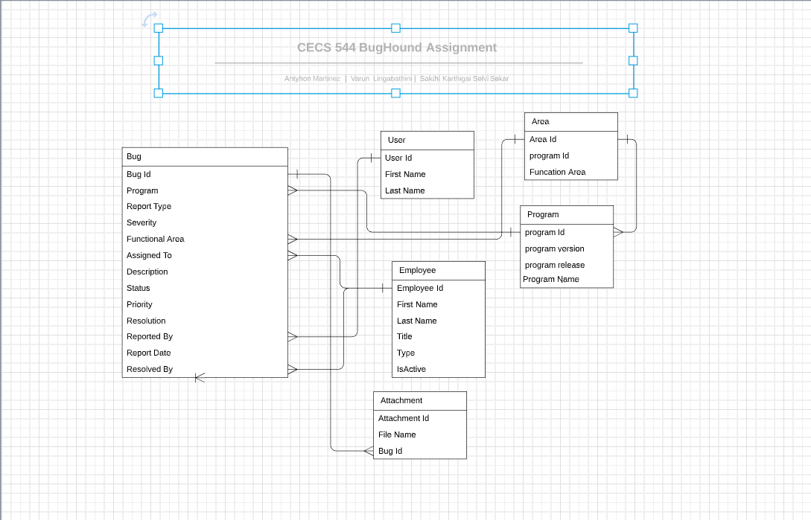

CREATE TABLE `User` (

`User Id` <type>,

`First Name` <type>,

`Last Name` <type>

);

CREATE TABLE `Area` (

`Area Id` <type>,

`program Id` <type>,

`Funcation Area` <type>

);

CREATE TABLE `Employee` (

`Employee Id` <type>,

`First Name` <type>,

`Last Name` <type>,

`Title` <type>,

`Type` <type>,

`IsActive` <type>

);

CREATE TABLE `Attachment` (

`Attachment Id` <type>,

`File Name` <type>,

`Bug Id` <type>

);

CREATE TABLE `Program` (

`program Id` <type>,

`program version` <type>,

`program release` <type>,

`Program Name` <type>

);

CREATE TABLE `Bug` (

`Bug Id` <type>,

`Program` <type>,

`Report Type` <type>,

`Severity` <type>,

`Functional Area` <type>,

`Assigned To` <type>,

`Description` <type>,

`Status` <type>,

`Priority` <type>,

`Resolution` <type>,

`Reported By` <type>,

`Report Date` <type>,

`Resolved By` <type>

);